





i

# Declaration

I (Sibundeni Sandile Ernest), declare that this report is my original work and that it has not been presented to any other university or institution for similar or any other degree award. It is being submitted for Engineering programming 3 (EIENP3A) to the Department of Electrical Engineering at the Vaal University of Technology, Vanderbijlpark.

…Sibundeni S.E…………………. ……16 June 2025…..

Signature Date

# Acknowledgement

|  |  |
| --- | --- |
| 223857548 | **MAZIBUKO, T** |
| 221717633 | NKGODI, N.N |
| 224144545 | MALATJI, MP |
| 221148183 | MPATA, MC |
|  |  |

**Dedication**

I dedicate this to Mr Dipo Ojo Seriki

# *TABLE OF CONTENTS*

Declaration ............................................................................................................................................ ii

Acknowledgement ................................................................................................................................ iii

Dedication ............................................................................................................................................. iv

List of tables ......................................................................................................................................... vii

List of Figures ....................................................................................................................................... ix

Acronyms & Abbreviations ................................................................................................................... x

Chapter 1: Introduction and purpose of the study ................................................................................. 1

1.1 Introduction .............................................................................................................................. 1

1.1. Background .......................................................................................................................... 1 -2

1.2. Problem statement……………………………………………………………………………………….……………………3

1.3. Significance of the study ........................................................................................................ 4

1.4. Objectives ................................................................................................................................ 5

1.5. Project plan .............................................................................................................................. 6

1.6. Proposed budget ...................................................................................................................... 7

1.7. Time Schedule ......................................................................................................................... 8

1.8. Limitations ............................................................................................................................... 9

1.9. Conclusion ............................................................................................................................. 10

Chapter 2: Research Design and Methodology .................................................................................... 11

2.1 Introduction ............................................................................................................................ 11

2.2 Scope of work.......................................................................................................................... 12

2.2.1 DHT22 temperature and humidity Sensor................................................................... 12-13

2.2.2 DS18B20 temperature sensor ............................................................................................ 14

2.2.3 Infra-red Sensor................................................................................................................. 15

2.2.4 LDR sensor ...................................................................................................................... 16

2.2.6 Microcontroller ........................................................................................................................... 17

2.2.7 Webserver ................................................................................................................................... 18

2.2.8 Database ..................................................................................................................................... 19

2.3Conclusion .................................................................................................................................. 20

Chapter 3: Hardware design ................................................................................................................. 21

3.1 Introduction ............................................................................................................................. 21

3.2 Hardware design ...................................................................................................................... 22

3.2.1 Electronic Circuit Designs.................................................................................................... 23

3.2.1.1 Microcontroller Circuit .................................................................................................... 23

3.2.1.2 DS18B20 temperature......................................................................................................... 24

3.2.1.3 DHT22 temperature and humidity sensor ................................................................... 25

3.2.1.4 LDR sensor............................................................................................................ 26-27

3.2.1.5 Infra-red ………………........................................................................................... 28

3.2.1.5 Main circuit design ………………… .......................................................................... 29

3.2.1.4 Wiring........................................................................................................................... 30-31

3.2.2 Breadboard and enclosure design .......................................................................................... 32-33

3.2.3 Safety precautions ……………………………………………………………………………34

3.3 Conclusion .....................................................................................................................................35 Chapter 4: Software design ............................................................................................................ 36

4.1 Introduction ................................................................................................................................... 36

4.2 Software designs ............................................................................................................... 37-43

4.3 Conclusion ................................................................................................................................... 44

Chapter 5: Results and Discussion ...................................................................................... 45

5.1 Introduction ............................................................................................................... 45

5.2 Findings ..................................................................................................................... 46

Chapter 6: Conclusions and Recommendations ................................................................................. 47

6.1 Conclusion ……………………………………………………………………………………………………………………..………...47

6.2 Recommendations ........................................................................................................................ 48

References ......................................................................................................................................... 49 Appendix ............................................................................................................................................. 50

## List of tables

Table 1: Budget 7

Table 2: Example of a Project Time Schedule 8

# List of Figures

Figure 1: Block diagram of the battery voltage monitoring module …………………………11

Figure 2: DHT22…………………………………………………………………………………….12

Figure3: DS18B20……………………………………………………………………………………14

Figure 4: Infrared………………………………………………………………………………………15

Figure 5: LDR…………………………………………………………………………………………..16

Figure 6:Microcontrller…………………………………………………………………………………17

Figure 7: Webserver…………………………………………………………………………………….18

Figure 8: Database……………………………………………………………………………………19

Figure 9: Block diagram………………………………………………………………………………23

Figure 10: Online microcontroller…………………………………………………………………….24

Figure 11:wokwi DS18B20……………………………………………………………………………25

Figure 12: wokwi DHT22……………………………………………………………………………..26

Figure 13: wokwi LDR……………………………………………………………….28

Figure 14: wokwi infrared………………………………………………………………29

Figure 15: wokwi full circuit …………………………………………………………………………31

Figure 16: Full circuit…………………………………………………………………………………34

Figure 17:Wi-Fi to database…………………………………………………………………….37

Figure 18: Flow chart…………………………………………………………………………39

Figure 19: use case…………………………………………………………………………….40

Figure 20: Arduino code…………………………………………………………………………42

## Figure 21: Python code……………………………………………………………43

Figure 22: database…………………………………………………………………………44

Figure 23: class diagram………………………………………………………………………45

Figure 24: user information…………………………………………………………………48

Figure 25: admin information………………………………………………………………48

Acronyms & Abbreviations

|  |  |
| --- | --- |
| LDR | Light Dependent Resistor |
| PIR | Passive Infra-Red |
| LDR | Light Dependent Resistor |
| DBMS | Database Management System |

|  |  |
| --- | --- |
| HTML | HyperText Markup Language |
| CSS | Cascading Style Sheets |
|  |  |
|  |  |

**Chapter 1: Introduction and purpose of the study**

## 1.1 Introduction and background

Within the supply chain, the gross impact of food spoiling during transportation show a serious safety and economic concern. Maintaining ideal climatic conditions is essential to ensuring product quality and consumer safety, especially for perishable items like meat. The real-time, detailed data required to handle these situations is frequently absent from traditional monitoring techniques, which could result in risks and costs. In contrast to the conventional static monitoring systems that run at set intervals, this necessitates the adoption of a system that can help with the appropriate monitoring and control of the meat's environment within a truck. The distribution of beef was revolutionized by the introduction of refrigerated vehicles, which improved the safety and dependability of long-distance transportation. In order to guarantee that consumers have access to safe and fresh products, meat transportation is also essential, supporting both public health and food security (Wilson, 2018).

Meat transportation is still a crucial component of the infrastructure that keeps our food supply safe, well-maintained, and delivered effectively as the demand for fresh meat rises and logistical difficulties become more significant. The absence of real-time monitoring and control of the truck's environmental conditions, which can result in problems like temperature swings and spoiling, has more impact in the meat transportation sector. This leads to needless product loss and possible health hazards. Ineffective meat monitoring systems can also have a negative impact on the environment and increase waste (Nguyen, 2020).

To address these challenges, the modern technology industry has introduced intelligent sensor systems and wireless communication technologies with advanced capabilities. These systems can be integrated into meat transportation trucks to make them more efficient and smarter. In several regions globally, these intelligent monitoring systems have been successfully designed and implemented to enhance the safety and quality of meat transportation (Morris, 2019).

By taking in intelligent sensor systems into meat transportation trucks, companies can improve product quality and reduce spoilage. These smart systems can automatically monitor and adjust environmental conditions based on predetermined parameters, such as temperature, humidity, and location. As a result, product loss is minimized, leading to cost savings and improved consumer safety (Alvarez, 2021).

Intelligent meat monitoring helps to improve supply chain accountability and traceability. These solutions contribute to a more secure and open environment for customers by guaranteeing that meat products are traced and monitored in real-time. Furthermore, preventative maintenance and prompt resolution of any potential problems are made possible by the capacity to remotely monitor and regulate vehicle conditions (Kumar, 2022).

Modernizing conventional meat transportation with intelligent monitoring systems has several advantages for customers and the food business, such as increased safety, better product quality, and less environmental effect. By utilizing technology to develop intelligent meat monitoring systems, transportation companies can set the path for a food supply chain that is more resilient and sustainable. To solve the problems with traditional meat transportation and build a safer, more effective food distribution system going forward, decision-makers must adopt these creative ideas (Roberts, 2023).

Nicholas Appert was a French inventor and chef who is known for inventing the process of canning, a way to preserve food for longer periods. In the early 1800s, Appert realized that sealing food in jars and then heating them could stop food from spoiling. This idea came about because there was a need to store food for the French navy to take on long trips. Appert’s method involved putting food in airtight containers and heating them to kill bacteria. This technique, later known as canning, became the foundation for the modern food preservation industry, making it possible to store food safely for much longer.

Louis Pasteur was a French scientist who made huge contributions to understanding how tiny living things, like bacteria, affect food and health. In the 1800s, he discovered that heating liquids like milk, wine, and beer to a certain temperature could kill harmful bacteria without ruining the drink. This process, called pasteurization, helped preserve these liquids and made them safer to consume. Pasteur’s work didn’t just change how we preserve food—it also helped prove that germs cause illness, which led to better hygiene in hospitals and everyday life. His discoveries have had a lasting impact on both food safety and health around the world.

## 1.2 Problem statement

Traditional meat transportation monitoring systems have been seen to only work with limited real-time data and fixed environmental thresholds, which has held up for a while, but this hasn’t proved to be an efficient way to curb unnecessary product spoilage and ensure adequate safety during transit. Consequently, the inefficiency of traditional systems results in significant product loss and contributes to an escalation in food safety risks

**Proposed solution**

This system will make use of intelligent sensor units that will be used to control and monitor the environmental conditions within the truck. This system will have the capability to access a database, where it will retrieve data for storage. This data can then be accessed by administrators and users, enabling them to make necessary adjustments at regular intervals to enhance the system's efficiency and ensure product safely.

## 1.3. Significance of the study

The implementation of a Smart Meat Monitoring System for trucks in transit has vital potential for improving food safety, reducing waste, and improve supply chain efficiency. Traditional meat transportation methods mostly rely on manual checks and wrong temperature readings, leading to potential spoilage and safety risks. An automated, real-time monitoring system addresses these issues with correct data. The important of implementing this smart meat monitoring system are listed below:

* Improve Food Safety and Quality Assurance: By continuously monitoring temperature, humidity, and other critical parameters, the system ensures that meat products remain within safe and optimal storage conditions
* Reduction of Food Waste and Economic Losses: This directly translates to reduced food waste and significant cost savings for meat producers and distributors.

* Improved Traceability: The system provides a comprehensive record of environmental conditions throughout the transit process, improving traceability and accountability. This is crucial for regulatory compliance and building consumer trust.

* Optimization of Logistics and Operational Efficiency: Data-driven insights from the system can be used to optimize transportation routes, predict potential issues, and improve overall logistics efficiency. Data analysis can be used to improve predictive maintenance of the refridgeration units on the trucks.

## 1.4. Objectives

The following are the project's main goals:

• To develop and implement a smart meat monitoring system that continuously measures and records temperature, humidity, and environmental conditions inside the truck during transit.

• To create a web-based dashboard that allows authorized users to view real-time sensor data, receive alerts, and generate transport condition reports.

• To combine IoT sensors and cloud storage for seamless data collection, remote access, and long-term analysis of meat transportation conditions.

## 1.6. Project plan

This project will be implemented using a methodical process that includes the following steps:

* First Phase: Design of the System choosing communication modules and temperature sensors.

creation of the data flow and system architecture.

* Phase 2: Implementation of Hardware The sensor is integrated outside the truck.

setting up cloud connectivity and the data collection device.

* Phase Three: Development of Software creation of a monitoring dashboard on the web.

installation of temperature deviation alert systems.

* Phase 4: Validation and Testing carrying out controlled experiments to confirm the accuracy of the system. adjusting the system in light of user input and test findings.

* Phase 5: Implementation and Assessment deployment of the monitoring system in the real world. Assessment and improvement of performance.

## 1.7 Proposed budget

Lists of components:

|  |  |
| --- | --- |
| Components | Prices |
| ESP32 wemo D1 | R275 |
| Temperature Sensor (x2) | R65 |
| Humidity Sensor | R35 |
| LDR | R30 |
| Infra-red Sensor | R45 |
| Connecting wires (x10) | R95 |
| Breadboard | R75 |
| Total | R631 |

## 1.8 Time Schedule

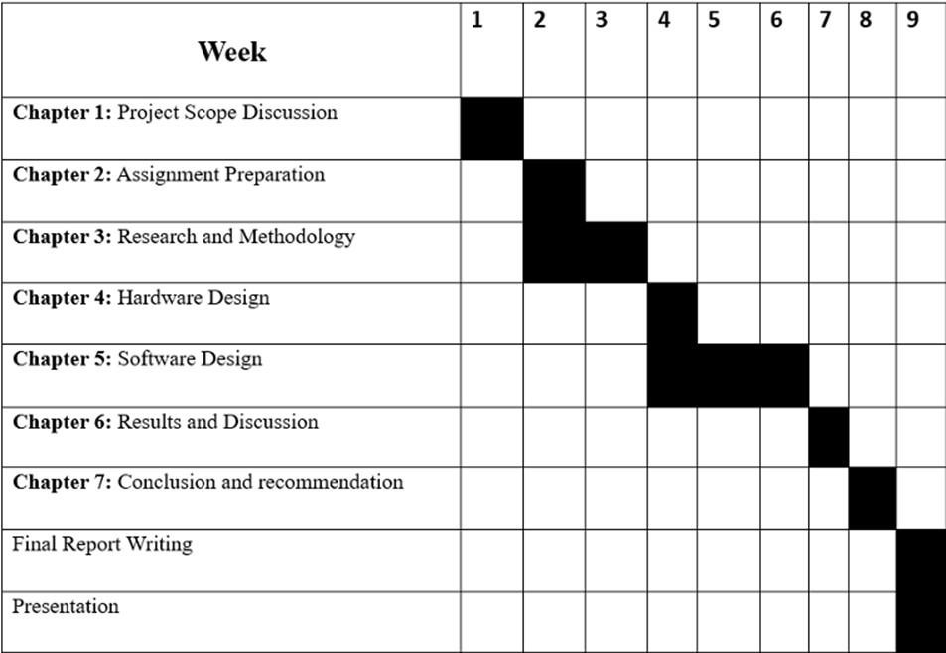

## 1.9 Limitations

The limitations of a study can be described as the shortcomings or weak points which could be the result of unavailability of resources, components, or equipment.

* Connectivity Issues: Weak network signals in remote locations can interfere with realtime monitoring.
* Power Supply: It can be difficult to guarantee constant power to sensors and communication modules during long-distance transportation.

* Environmental Factors: Sensor readings may be impacted by outside circumstances like severe weather.
* Data Security: To stop data manipulation, the system needs to be safe from online attacks.

## 1.10 Conclusion

To guarantee food safety, compliance, and supply chain efficiency, a smart meat monitoring system must be put in place while the meat is in transit. The suggested solution seeks to improve overall food logistics management, decrease spoilage, and increase operational transparency by combining IoT technology with real-time monitoring capabilities. Stakeholders may make well-informed decisions to uphold the highest standards of food transportation with the help of automatic notifications and ongoing monitoring.

**Chapter 2: Research Design and Methodology**

## 2.1 Introduction

The system is equipped with advanced sensors to monitor critical environmental factors such as humidity, temperature, infra-red and LDR within and outside the truck's storage area. These sensors are integrated with a central microcontroller, which processes the collected data and transmits it to a webserver for real-time monitoring and storage in a database.

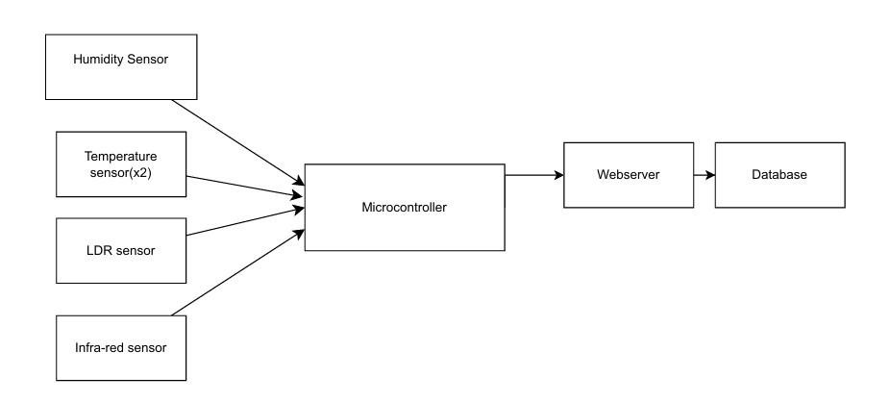

Figure 1: Block diagram of the battery voltage monitoring module

## 2.2 Scope of work

### 2.2.1 DHT22 temperature Sensor

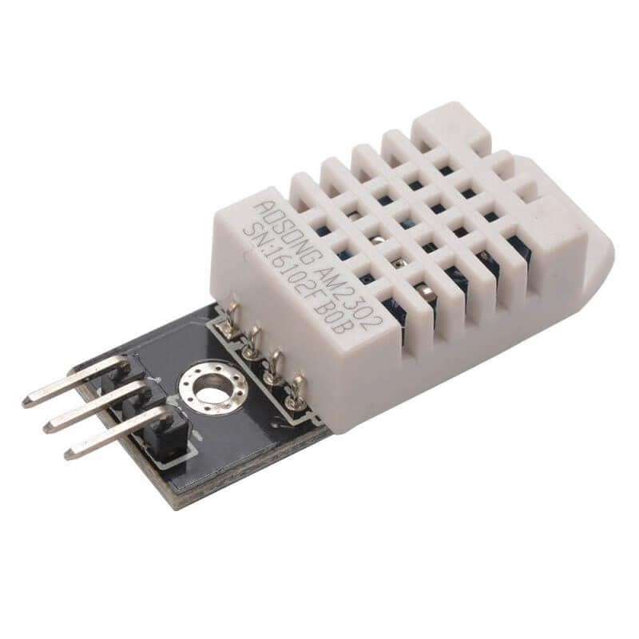

Figure 2: DHT22

Adafruit Industries, 2023. AM2302 (DHT22) temperature-humidity sensor module [image]. Available at: https://www.adafruit.com/product/393 [Accessed 15 May 2025].

The DHT22 sensor is preferred for meat transit monitoring because it combines both temperature and humidity sensing in one compact device. While the LM35 is highly accurate for temperature measurements, it doesn't provide humidity data, requiring additional sensors for complete monitoring. Similarly, the TMP36, being an analog sensor, demands more complex circuitry and doesn't measure humidity either. The DHT22 stands out for its ability to track both temperature and humidity simultaneously, simplifying system design and reducing costs while ensuring comprehensive environmental monitoring.

the DHT22 sensor enables real-time temperature and humidity monitoring, providing critical data to maintain optimal conditions. The system can trigger cooling mechanisms if temperatures rise or other adjustments to preserve the meat’s quality.

The humidity sensor measures the water content in its environment, which can be adapted to monitor humidity levels in the truck's storage area. By detecting changes in moisture, it provides real-time data on the change in humidity, which is critical for maintaining optimal conditions for meat preservation.

## Importance in the Project

* Preservation of Meat Quality: Humidity control is essential to prevent the meat from drying out or becoming overly moist, which could compromise its texture and taste.
* Prevention of Bacterial Growth: High humidity levels can create a breeding ground for bacteria. Monitoring and maintaining appropriate humidity levels help mitigate this risk, ensuring food safety.

## 2.2.2 DS18B20 temperature sensor

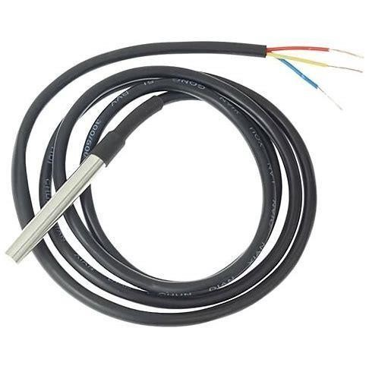

Figure3: DS18B20

HiLetgo, 2023. DS18B20 Waterproof Digital Temperature Sensor Probe [image]. Available at: <https://www.amazon.com/dp/B01IK9GEQG> [Accessed 15 May 2025].

When monitoring external temperatures, the DS18B20 is chosen over other temperature sensors due to its durability and adaptability in outdoor conditions. Sensors like thermistors might struggle with calibration in extreme weather, and RTDs (Resistance Temperature Detectors) could be less cost-effective for similar accuracy levels. The DS18B20, on the other hand, stands out for: • Its waterproof housing, which protects it from rain and other environmental moisture.

* Simple integration with microcontrollers via the 1-Wire protocol, enabling scalable and efficient data collection.
* Low power consumption, making it suitable for continuous operation during transportation.

.

## 2.2.3 Infra-red Sensor

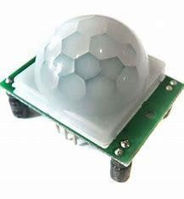

Figure 4: Infrared

HC-SR501 PIR Motion Sensor [image]. Available at: <https://www.amazon.com/> [Accessed 15 May 2025].

Infrared sensors were chosen for this project because they are less affected by external environmental conditions such as wind, noise or vibrations. Other sensors like PIR sensors are more affected by extreme temperature variations and may struggle to adapt to diverse outdoor conditions during transit.

Infrared sensors enhance the overall functionality of smart meat monitoring systems by ensuring the truck's security during transportation. They detect unauthorized human movement near the truck, preventing tampering or theft of refrigerated goods

## 2.2.4 LDR sensor

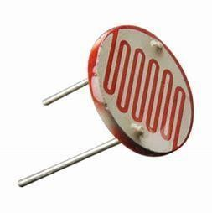

Figure 5: LDR

LDR (Light Dependent Resistor) [image]. Available at: <https://www.amazon.com/> [Accessed 15 May 2025].

The LDR (Light Dependent Resistor) is preferred for light intensity monitoring in smart meat transit systems because of its cost-effectiveness and straightforward operation. While photodiodes are highly responsive and offer wide sensing detection, they require increasing system complexity. Similarly, phototransistors, although more sensitive than photodiodes, they cost more money and may provide unnecessary sensitivity detection needs. The LDR is chosen for its simplicity and affordability, making it an ideal choice for light-based monitoring in practical.

The LDR enables reliable detection of sensor light changes, which is critical for maintaining optimal conditions during meat transportation. For instance, a sudden increase in light levels inside the truck's refrigerated compartment might indicate that a door has been left opened by lighting, which protect the meat's quality.

## 2.2.6 Microcontroller

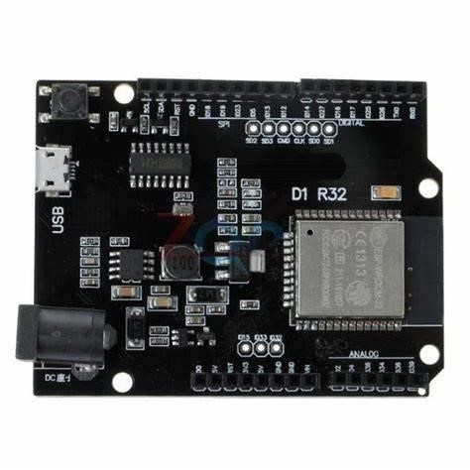

Figure 6: Microcontroller

ESP32 Development Board (e.g., D1 R32) [image]. Available at: <https://www.amazon.com/> [Accessed 15 May 2025].

The ESP32 microcontroller is preferred for smart meat monitoring systems during transit because of its built-in Wi-Fi and Bluetooth capabilities, as well as its ability to handle complex tasks efficiently. While the Arduino Uno is a widely popular and beginner-friendly choice, it lacks built-in wireless communication features, which are essential for real-time data transmission in smart systems. Similarly, the Raspberry Pi, though powerful and versatile, is more expensive and consumes higher energy, making it less suitable for battery-powered applications like meat transit monitoring. The ESP32 stands out for its low power consumption, integrated wireless connectivity, and ability to support multiple sensors simultaneously, simplifying system design and reducing operational costs.

The ESP32 microcontroller enables seamless integration of temperature and humidity sensors, providing real-time data that ensures optimal conditions for meat during transit. With its wireless communication features, it can transmit critical environmental data to monitoring systems, allowing for immediate adjustments to cooling or ventilation mechanisms as needed. This capability helps prevent spoilage, maintain meat quality, and minimize wastage during transportation, ensuring the meat reaches its destination in excellent condition.

## 2.2.7 Webserver



Figure 7: Webserver

Server and Globe Icon [image]. Available at: [https://www.example-stock-image-site.com/](https://www.google.com/search?q=https://www.example-stock-image-site.com/&authuser=2) [Accessed 15 May 2025].

A web server is a computer system capable of delivering web content to end users over the internet via a web browser. It is a vital component in web-based systems, enabling functionalities such as user authentication, accessing nodes, administrative controls, data logging, and analysis.

HTML: Structures the web pages for functionality and organization.

CSS: Style the interface to ensure it’s visually appealing and responsive.

JavaScript: Provides interactivity, real-time updates, and data visualization.

Python and Flask: Manages backend logic, processes data from the ESP32 microcontroller, communicates with the database, and serves the web pages.

## 2.2.8 Database Webserver



Figure 8: Database

Available at: <https://www.mysql.com/about/legal/trademark.html> [Accessed 15 May 2025].

A database is essentially a structured collection of data stored electronically, designed for efficient retrieval, management, and updating. It is controlled by a Database Management System (DBMS), which acts as the interface between the database and its users or applications. Databases are commonly organized in tables, with rows and columns, and relational databases use SQL (Structured Query Language) for querying and managing data.

The database securely stores all the collected data, making it accessible for real-time monitoring and analysis. This ensures that stakeholders can track the conditions of the meat during transit and take corrective actions if necessary.

## 2.3 Conclusion

The goal of this project is to ensure seamless communication between all components of the system. Data collection from environmental sensors is crucial for maintaining optimal conditions during the transport of meat. Effective communication between system parts is essential for integrating the system with broader logistics networks and enabling future upgrades. The conclusion highlights the importance of robust communication within the system. Efficient data sharing and a clear understanding of each component's functionality are vital for preserving meat quality in transit. Moving forward, continuous improvements will contribute to safer and more reliable food transportation systems. The next section will focus on the hardware design of the project, detailing how the microcontroller interfaces with the various components discussed in the previous chapter.

## Chapter 3: Hardware design

## 3.1 Introduction

In this chapter, we detail the hardware design of the smart meat monitoring system for in-transit trucks. Expanding on the methodology outlined in Chapter 2, this chapter elaborates on the specific hardware requirements and the design process for the system's components. The primary hardware components include the ESP32 microcontroller; DS18B20 temperature sensors (for outside temperature), DHT22 temperature and humidity sensors (for inside conditions), infrared sensors, LDR sensors, and resistors. This chapter also presents the circuit diagrams for each part of the system, describes the assembly process, and discusses the tests conducted to ensure the functionality and accuracy of the hardware.

## 3.2 Hardware design

The hardware design for the smart meat monitoring system is composed of several interconnected modules. Each module plays a crucial role in the overall functionality of the system. The primary components include the ESP32 microcontroller, DS18B20 temperature sensors (for outside temperature), DHT22 temperature and humidity sensors (for inside conditions), infrared sensors, LDR sensors, and resistors. Below, we describe the design and integration of these components for monitoring meat during transit in a truck

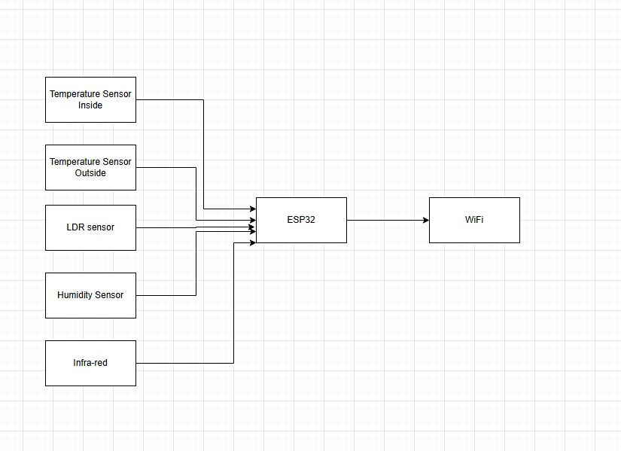

Figure 9: Block diagram

### 3.2.1 Electronic Circuit Designs

#### 3.2.1.1 ESP32 Microcontroller circuit design

The hardware design for the smart meat monitoring system comprises several interconnected modules, each playing a crucial role in the system's overall functionality. Primary components include the ESP32 microcontroller, DS18B20 temperature sensors (for outside temperature), DHT22 temperature and humidity sensors (for inside conditions), infrared sensors, LDR sensors, and resistors. The ESP32 microcontroller serves as the central unit, processing data from the various sensors and managing the system's overall operation by reading outside temperature from DS18B20 sensors, collecting inside temperature and humidity readings from DHT22 sensors, gathering data related to the presence or absence of meat from infrared sensors, and monitoring light levels (potentially indicating door open/close status) using LDR sensors. The ESP32 processes this sensor data to monitor temperature and humidity levels against predefined thresholds, detect the presence or absence of meat, and log any deviations or critical events. It also controls and communicates by triggering alerts or alarms based on the processed data (e.g., if temperature exceeds safe limits) and facilitating data transmission to a remote server or monitoring station for real-time tracking and analysis. The ESP32 is powered by a stable voltage source, ensuring continuous operation during transit, and its analog-to-digital converter (ADC) is calibrated to accurately read input from the sensors, enabling effective monitoring of meat conditions during transit to ensure quality and safety.

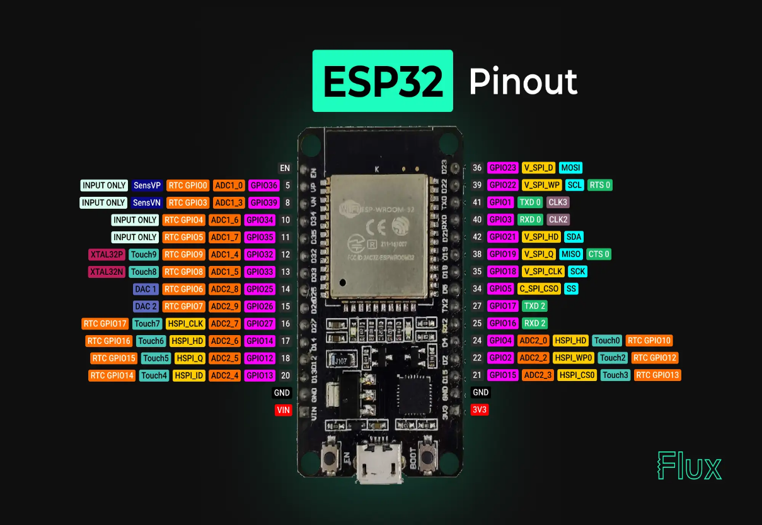

Figure 10: Online microcontroller

Flux. (n.d.). *ESP32 Pinout*. Retrieved from <https://www.flux.ai/p/blog/esp32-pinout-everything-you-need-to-know>

Figure 5: Circuit diagram of the ESP32

#### 3.2.1.2 DS18B20 temperature Sensor

DS18B20 temperature sensors play a crucial role in ensuring the safe transport of meat by precisely measuring the outside temperature of the truck. These robust sensors provide accurate and reliable temperature readings, which are essential for maintaining optimal conditions within the cargo hold. The ESP32 microcontroller, the system's central processing unit, properly reads the outside temperature data transmitted by the DS18B20 sensors. This real-time information is then processed by the ESP32 to monitor temperature levels, ensuring they remain within predefined safety thresholds. Any deviations or critical events, such as a sudden temperature spike, are promptly detected and logged by the system. This allows for immediate corrective action, safeguarding the quality and integrity of the meat throughout its journey. By continuously tracking and analysing temperature data, the system helps to prevent spoilage and ensures that the meat arrives at its destination in perfect condition.

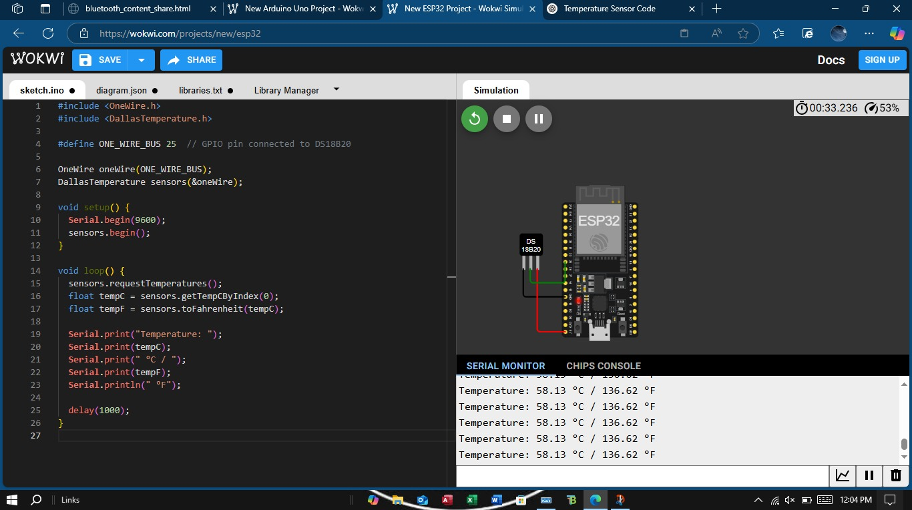

Figure 11:wokwi DS18B20

#### 3.2.1.3 DHT22 temperature sensor

The DHT22 sensor plays a crucial role in monitoring the inside temperature of the truck, providing essential data for preserving meat quality during transport. The ESP32 microcontroller collects this real-time temperature information, enabling continuous monitoring of the environment. This data is then processed to ensure that temperature levels remain within predefined safety thresholds, preventing spoilage. The system is designed to detect and log any temperature deviations, such as sudden changes, allowing for prompt corrective action. By diligently monitoring the inside temperature, the DHT22 sensor helps to uphold stringent health and safety regulations, ensuring the meat arrives at its destination in perfect condition.

A humidity sensor can be incorporated into the smart meat monitoring system to monitor the humidity levels inside the truck. The humidity sensor measures the amount of moisture in the air inside the truck. This is important because high humidity levels can create an environment that is conducive to bacterial growth, which can lead to spoilage of the meat. By monitoring the humidity levels, the system can help to ensure that the meat is transported in a safe and healthy environment. The data from the humidity sensor can be used to trigger an alert if the humidity levels exceed a certain threshold

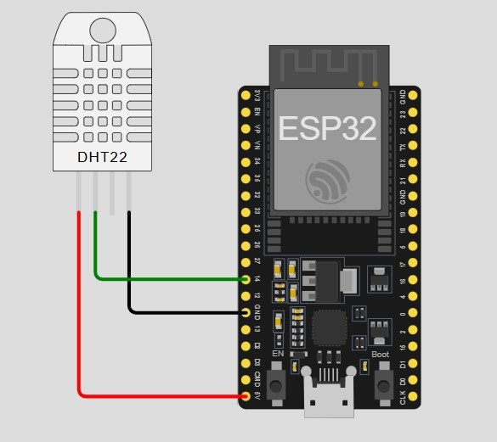

Figure 12: wokwi DHT22 connection

#### 3.2.1.4 LDR sensor

The LDR sensor can be incorporated into the smart meat monitoring system to monitor light intensity within the truck. The LDR's resistance changes based on the amount of light it receives. As light intensity increases, its resistance decreases, and vice versa. This change in resistance is used in a voltage divider circuit with a 10kΩ resistor. One terminal of the LDR is connected to the 3.3V supply from the ESP32 microcontroller, while the other terminal is connected to the ESP32's analog input pin (A0) and the resistor. The resistor is connected to the ground, creating a voltage that varies with light intensity. The ESP32 reads this voltage through its analog input, converting it into a digital value that represents the current light conditions inside the truck. This real-time data can be used to detect events such as the opening and closing of the truck doors, which could compromise the security and temperature stability of the meat truck.

**LDR Voltage Divider and Formula:**

* LDRs are often used in a voltage divider circuit. A common configuration is to connect the LDR in series with a fixed resistor (R). The voltage across the LDR (or the fixed resistor) changes with the LDR's resistance, which varies with light intensity.
* Here's the formula to calculate the voltage (Vout) across the fixed resistor (R):
  + Vout = (R / (R + LDR)) * Vin
  + Where:
    - Vout is the output voltage (the voltage you would measure).
    - R is the resistance of the fixed resistor.
    - LDR is the resistance of the LDR (which changes with light).
    - Vin is the input voltage (the supply voltage).

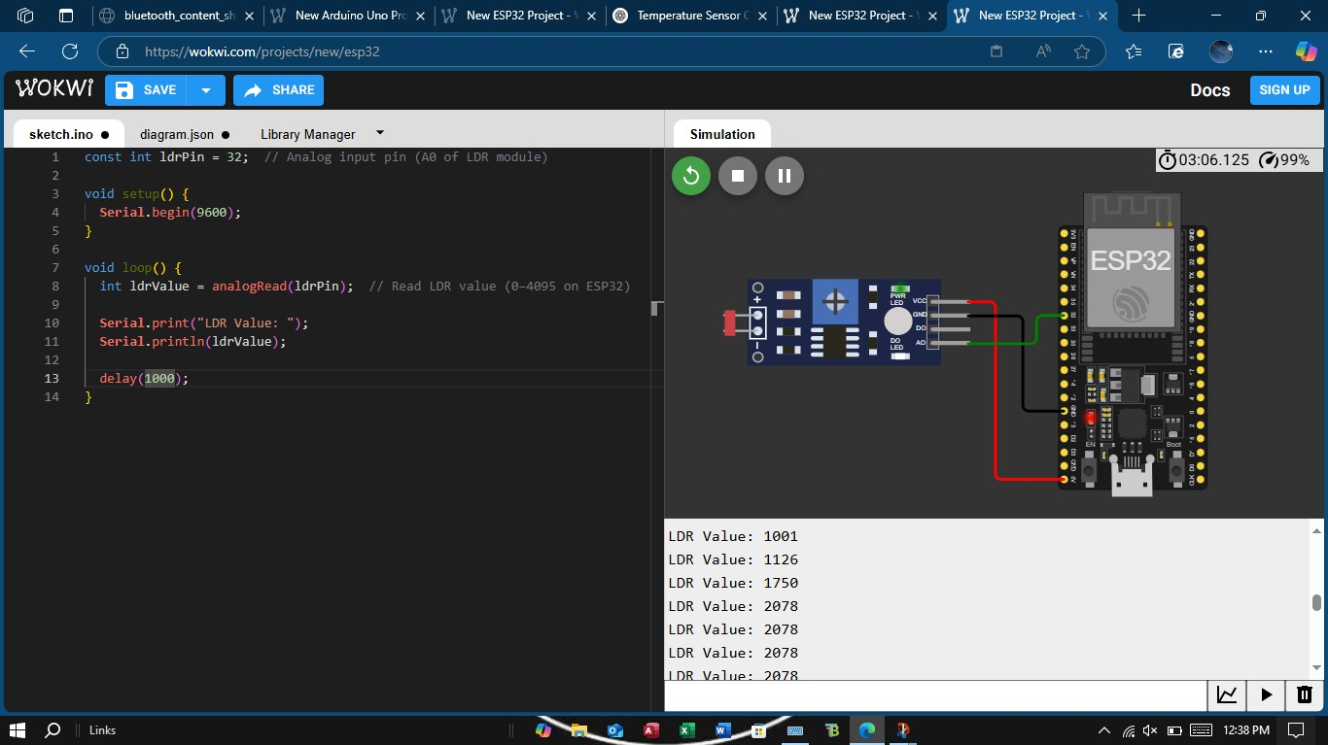

Figure 13: wokwi LDR

.

#### 3.2.1.6 Infra-red

An infrared (IR) sensor can be incorporated into the smart meat monitoring system to monitor the presence or absence of meat within the cargo area of the truck. The IR sensor works by emitting infrared light and detecting the reflected light. If an object, such as meat, is present, the reflected light is detected by the sensor. If no object is present, the light is not reflected back, and the sensor does not detect it. This information can be valuable for several reasons, including cargo verification, ensuring that the meat is loaded correctly at the origin and remains present throughout the journey; theft detection, detecting unauthorized removal of meat during transit; and inventory management, providing real-time data on the presence and location of the meat within the truck. The data from the IR sensor can be used to trigger an alert if the presence of the meat changes unexpectedly.

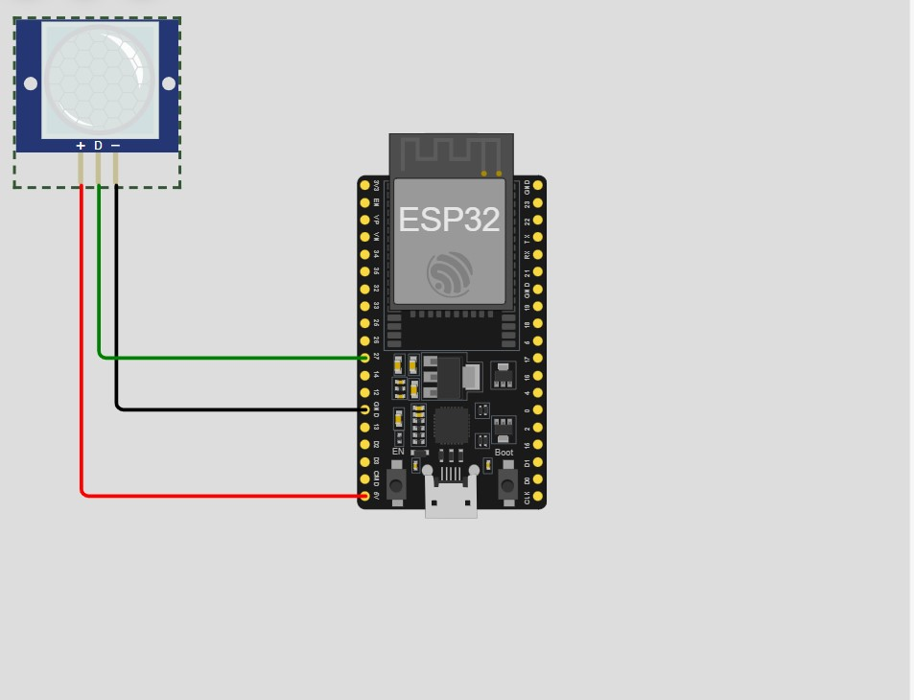

Figure 14:wokwi infrared

#### 3.2.1.5 Main circuit design

In the main circuit design, we discuss the overall design of the main circuit board that serves as the central hub for the smart meat monitoring system in transit trucks. This main circuit board integrates various components, including the ESP32 microcontroller, DS18B20 sensor, DHT22 sensor, infrared sensor, LDR sensor, humidity sensor, power supply components, and any other necessary peripherals.

1. ESP32 Microcontroller: The brain of the system, responsible for processing sensor data from the DS18B20, DHT22, infrared, LDR, and humidity sensors; controlling any necessary actuators or indicators; and managing communication with external devices.
2. DS18B20 Sensor: Measures outside temperature, providing data to the ESP32 to monitor environmental conditions.
3. DHT22 Sensor: Measures inside temperature and humidity, providing crucial data to the ESP32 to ensure the meat is stored in optimal conditions.
4. Infrared Sensor: Detects the presence or absence of meat within the cargo area, providing data to the ESP32 for cargo verification, theft detection, and inventory management.
5. LDR Sensor: Monitors light intensity, which can be used to detect events such as the opening and closing of truck doors, and provides data to the ESP32.
6. Humidity Sensor: Measures the humidity inside the truck.
7. Power Supply Components: Ensure stable power distribution to all components on the circuit board, including the ESP32 and all the sensors.

\ 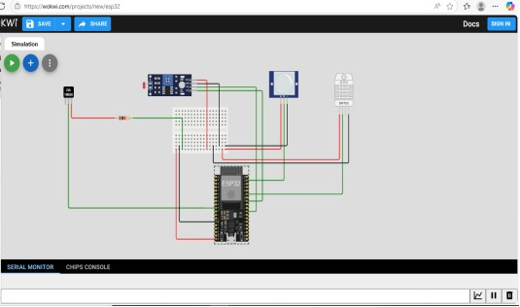

Figure 15: wokwi full circuit

#### 3.2.1.4 Wiring

Proper wiring is crucial for the reliable operation of the smart meat monitoring system. Here's a breakdown of the wiring requirements and how they will be addressed:

* **Sensor Wiring:**
  + Each sensor (DS18B20, DHT22, infrared, LDR, and humidity) will be connected to the ESP32 microcontroller on the main circuit board.
  + Wiring will be kept to a minimum length to reduce signal noise and voltage drops. o Shielded cables will be used where necessary, particularly for longer runs or in areas with potential electromagnetic interference (EMI).
  + Connectors will be used to allow for easy connection and disconnection of sensors, facilitating maintenance and replacement.
* **Power Supply Wiring:**
  + A stable power supply will be provided to the ESP32 and all sensors. o Power supply wiring will be sized appropriately to handle the current requirements of all components. o Voltage regulators on the main circuit board will ensure that each component receives the correct voltage. o Decoupling capacitors will be used near each component to filter out noise and ensure stable operation.
* **Grounding:**
  + A star grounding scheme will be implemented to minimize ground loops and reduce noise.
  + All ground connections will be made to a central ground point on the main circuit board.
  + The ground plane on the circuit board will be designed to provide a low-impedance path for ground currents.
* **Labeling and Organization:**
  + All wires and connectors will be clearly labeled to indicate their function and destination.
  + Wiring will be organized using cable ties, clips, or other methods to ensure a neat and tidy installation. o A wiring diagram will be created to document all connections.

### 3.2.2 Breadboard and enclosure design

The smart meat monitoring system is designed for in-transit trucks and employs several sensors to ensure meat safety and quality. Key hardware components include the ESP32 microcontroller, DS18B20 (outside temperature), DHT22 (inside temperature and humidity), infrared (meat presence), LDR (light intensity), and humidity sensors. These components are integrated onto a main circuit board, with careful consideration given to component placement, signal routing, power distribution, and grounding. Proper wiring, including shielded cables and clear labeling, is crucial for reliable operation. The final build involves transitioning from a breadboard to a Printed Circuit Board (PCB). This comprehensive design effectively monitors meat conditions during transport.

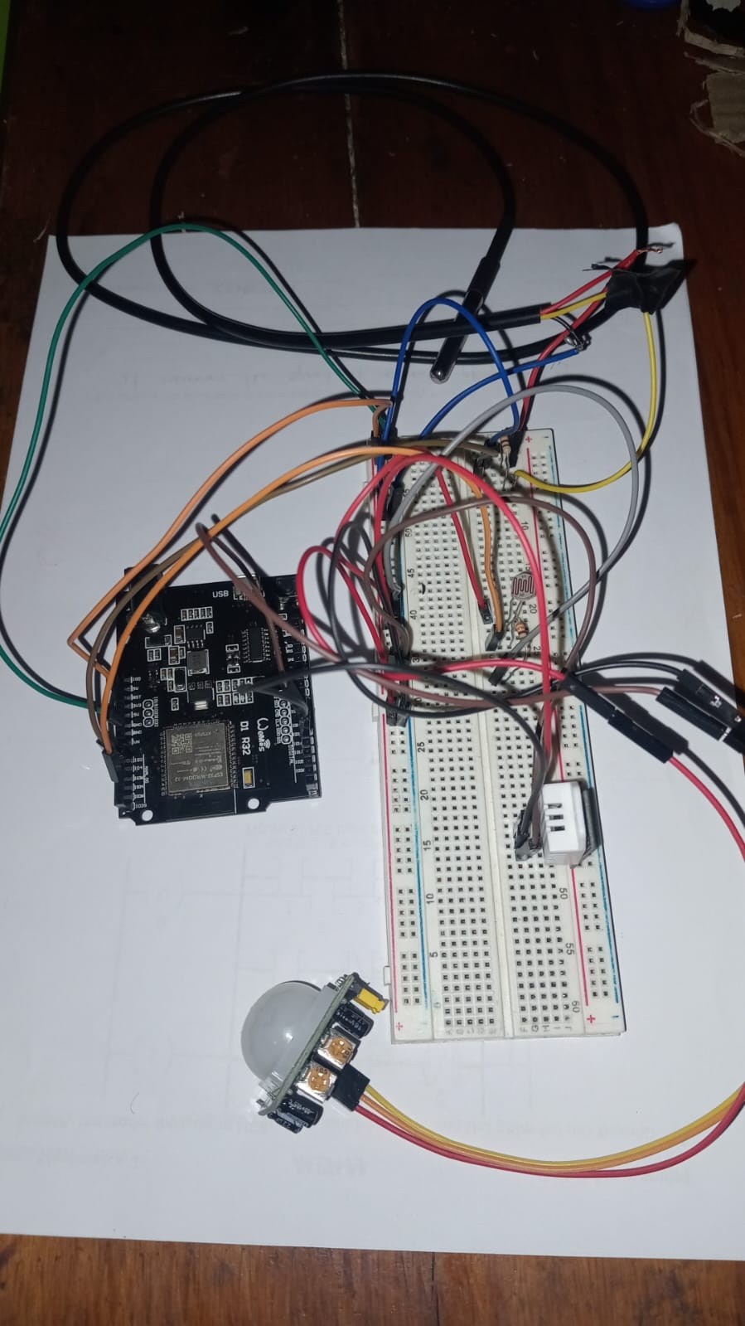

Figure 16:Full circuit

**3.2.3 Safety precaution**

* Calibrated Sensors: Ensure temperature sensors are accurately calibrated
* Use 3.3V for the microcontroller so that it won’t burn the components
* Safety**:** Ensure the power supply is properly insulated and protected to prevent short circuits and electrical hazards.

## 3.3 Conclusion

This chapter was for explaining about how the components read values how to connect them, it also state why did we prefer that one instead of the other component. It also state what you should be aware of when doing the connection .

.

**Chapter 4: Software design of (Smart Meat Monitoring System While in Transit)**

## 4.1 Introduction

This research design details a sensing circuit for a comprehensive system to monitor meat during truck transport. Careful selection and design of each component ensures accurate, real-time tracking and management of environmental conditions. The integration of these components will enable transporters to uphold meat safety, enhance truck quality, and comply with regulations through precise condition management.

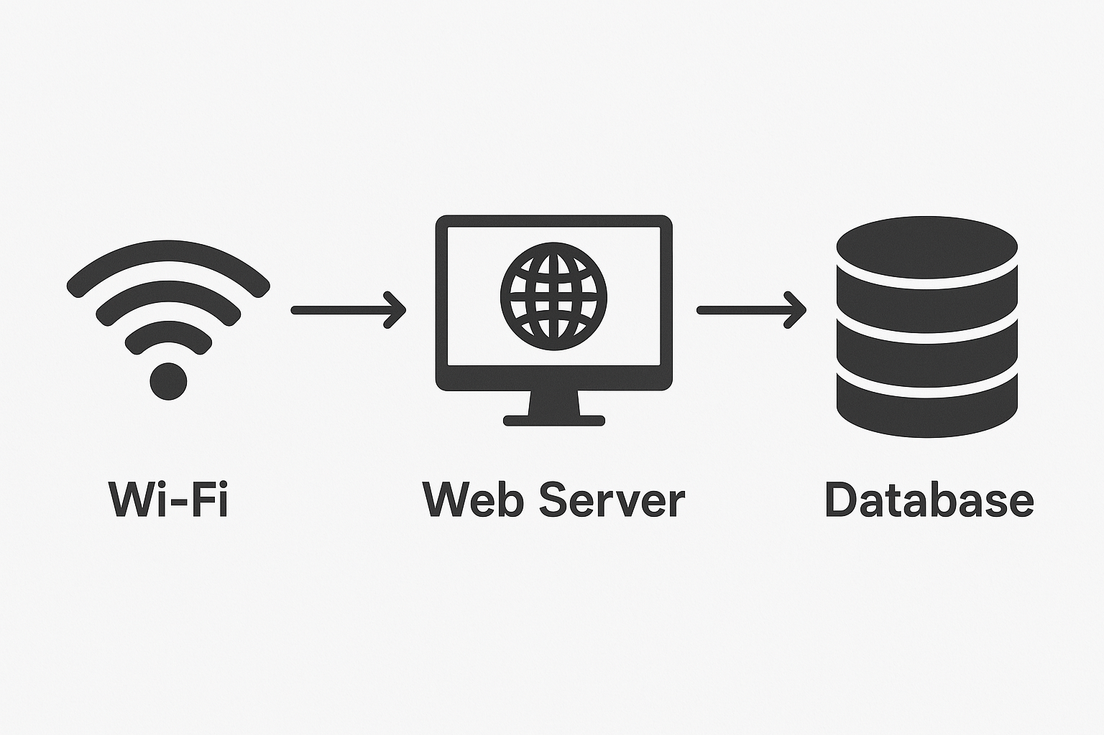

Figure 17:Wi-Fi to database

## 4.2 Software designs

In this section you need to mention that the software design will consist out of certain parts. Start with showing a flow diagram for the complete software design for the project. This means that your software must provide support for example, digital Inputs, sensors Inputs and analogue Inputs. This means for a certain input criterion presented, will result in generating certain output criteria.

A flow diagram should illustrate this criterion. Example: If Input A is triggered, the Output relay will switch, and a Light will be turned on.

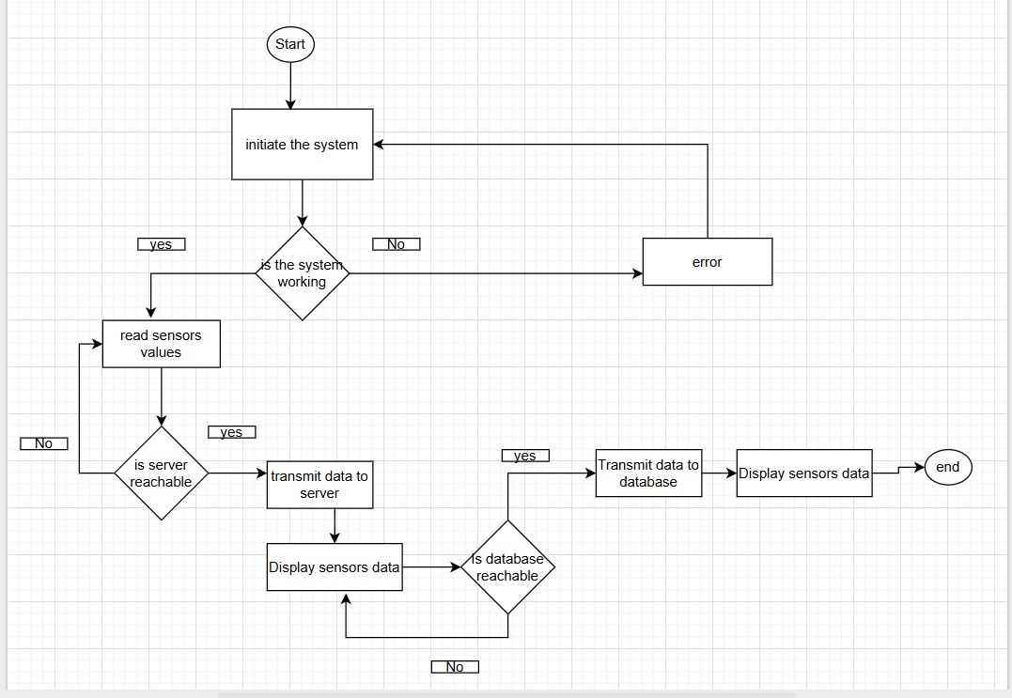

Figure 18: Flow chart

**4.2.1. Use Case**

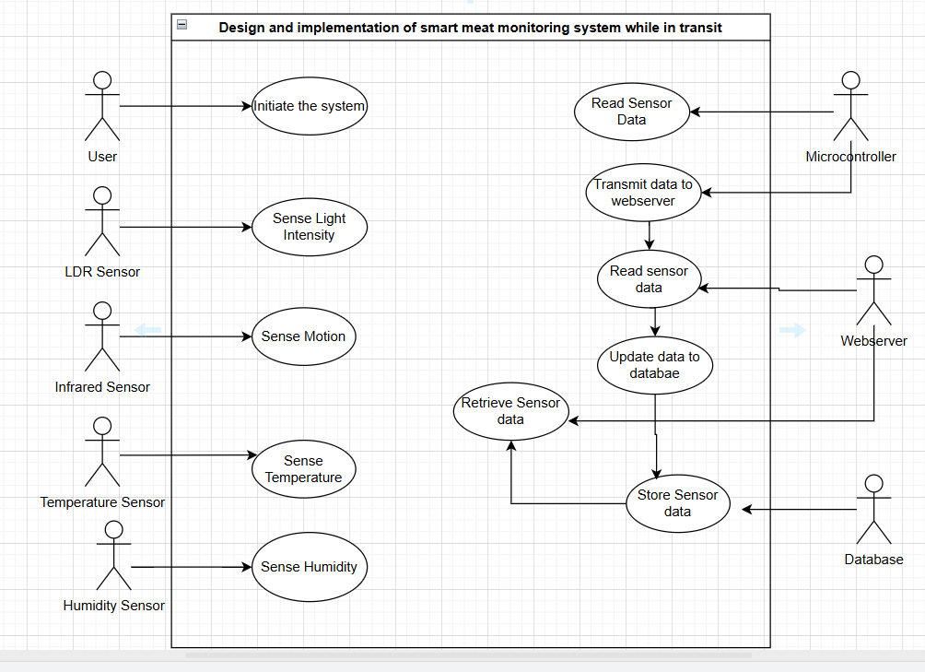

Figure 19: use case

**4.2.2ARDUINO IDE**

The code of json within the Arduino IDE is crucial for programming the ESP32 microcontroller, which acts as the central hub of the smart meat monitoring system. This code handles the essential tasks of reading data from the various sensors, including the DS18B20, DHT22, LDR, and infrared sensors, and then processing this raw data into a usable format. Finally, the processed data is transmitted to another application, such as a Python program, for further analysis, storage, and display.

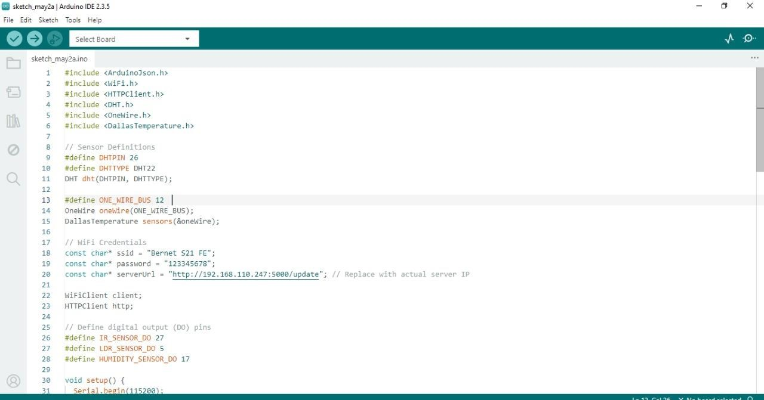

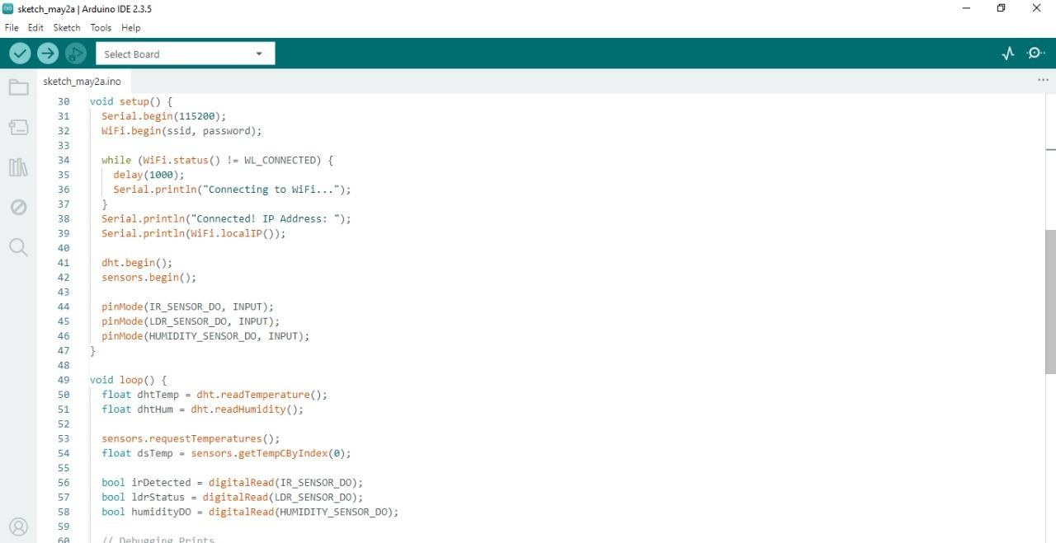

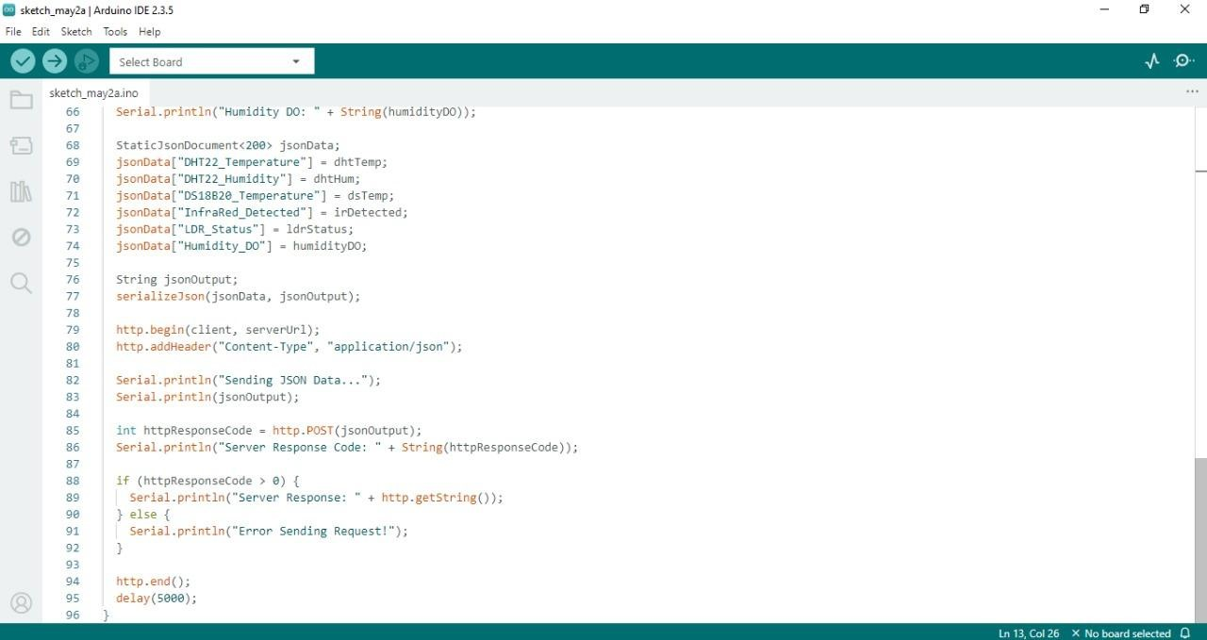

Figure 20: Arduino code

**4.2.3PYTHON**

These HTML files define the structure and content of the web pages, representing different pages or sections of the web application, such as login pages or data display pages. The HTML pages will contain elements that users see in their web browser. The data from the sensors is probably being sent from the ESP32, processed by the Python code (in TH.py), and then displayed on these HTML pages. In essence, Python (Flask) acts as the backend, handling logic, data processing, and database interaction, while the HTML files are the frontend, defining how the data and application are presented to the user in a web browser.

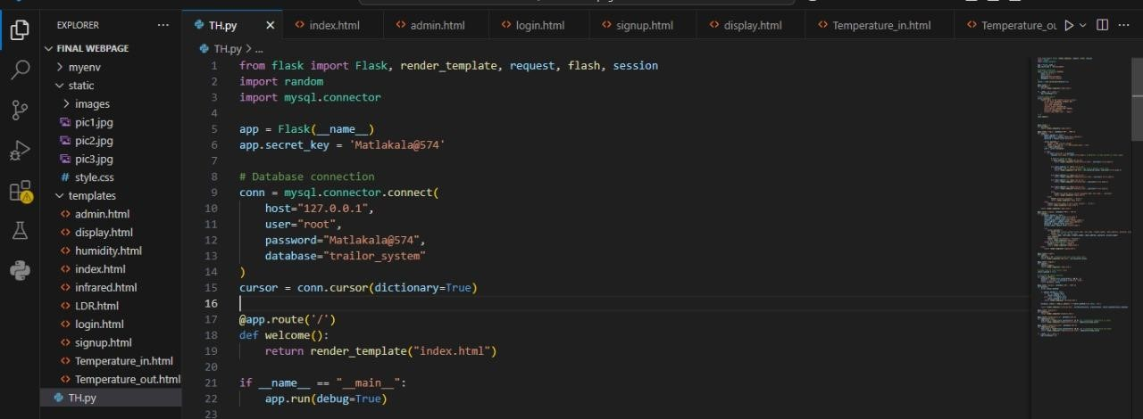

## Figure 21: Python code

## 4.2.4DATABASE

the MySQL database is used to store and manage data related to users or accounts or sensors within "trailor_system" application, and the Python code (Flask) interacts with it. It also being used to retrieve stored data.

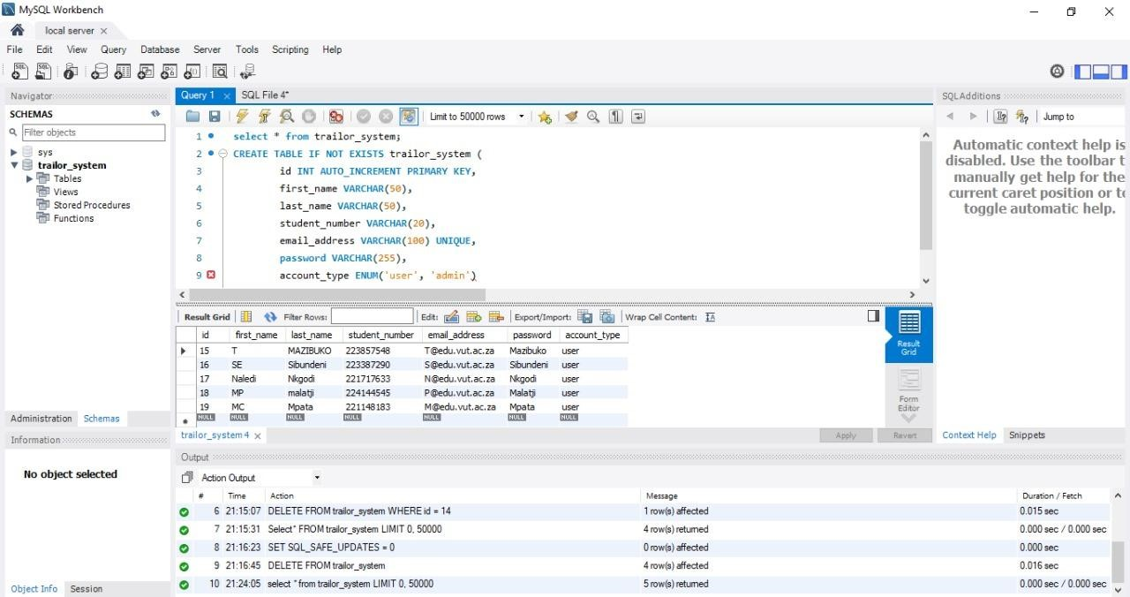

Figure 22: database code

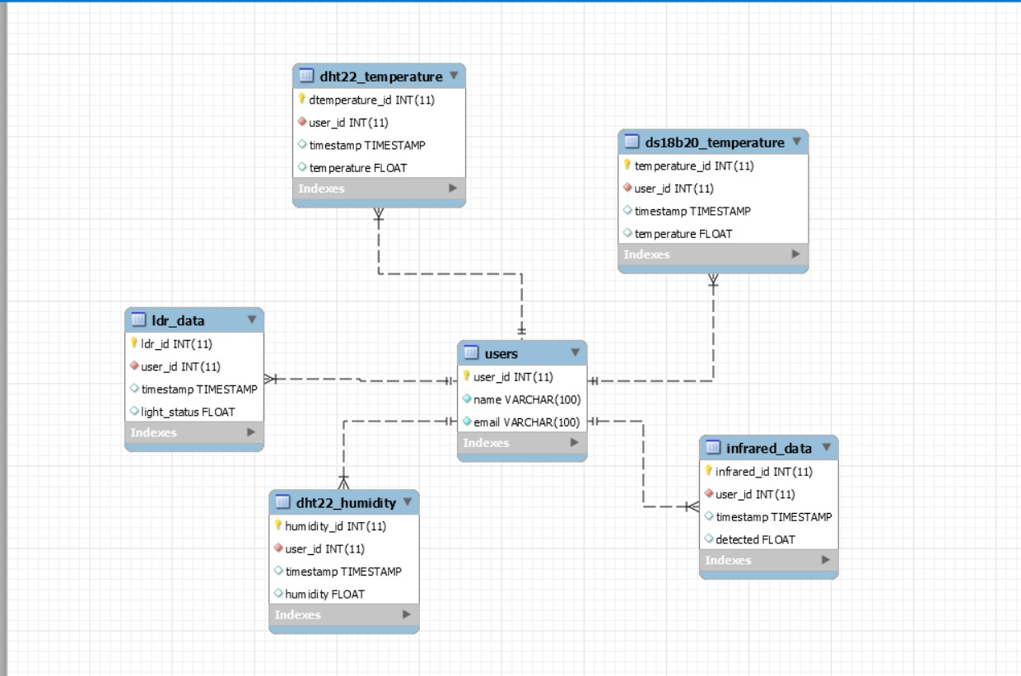

Figure 23: class diagram

## 4.3 Conclusion

In conclusion, the research design incorporates a microcontroller, various sensors, and a database to create a comprehensive monitoring system for meat during truck transport. Each component has been carefully selected and designed to ensure accurate real-time monitoring and control of environmental and security conditions. The integration of these components will enable transporters to uphold meat safety, enhance cargo quality, and comply with regulations through precise condition management.

**Chapter 5: Results and Discussion  
5.1 Introduction**  
This chapter shows the reading value of the user and the administrator for smart meat monitoring food system while in transit

**5.2 Findings**

**user**

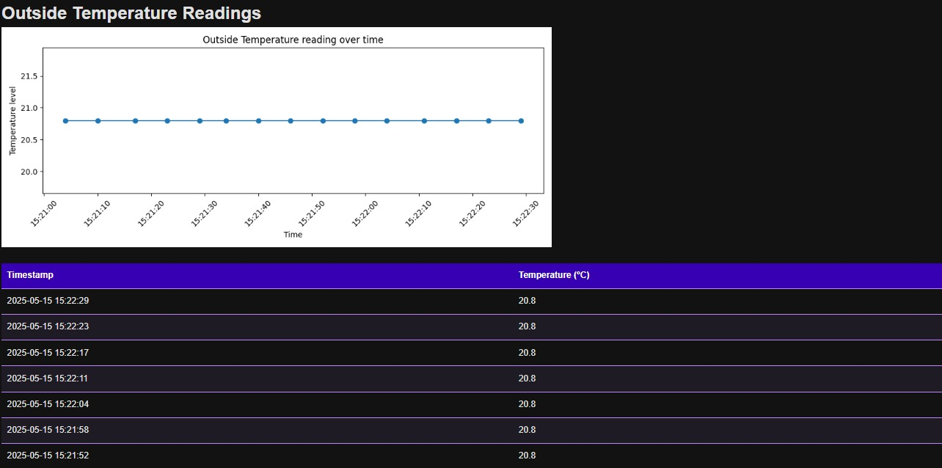

Figure 24: user information  
**admin**

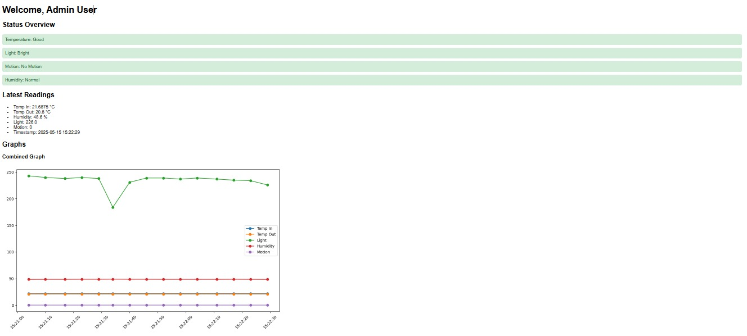

Figure 25: admin information

**Chapter 6**

**6.1 Conclusions**

The development of the Smart Meat Monitoring System while in transit has provided valuable insights into the integration of IoT technologies for food safety and logistics. Throughout the project, several outcomes were achieved, including real-time monitoring, data transmission via WiFi, and live data display through a web-based dashboard.

During the build phase, a number of challenges were encountered. One of the major problems was the instability of WiFi connectivity during long-range testing, especially in environments with poor network coverage. This issue was addressed by optimizing the ESP32’s WiFi reconnection logic and ensuring buffered data transmission to prevent data loss. Additionally, sensor calibration was a challenge, particularly ensuring the DHT22 and DS18B20 sensors delivered accurate and consistent readings. This was solved through repeated testing and cross-checking with reference instruments.

Another shortcoming was the initial data delay between the ESP32 and the web dashboard, which was mitigated by streamlining the Python Flask backend and optimizing JSON data parsing. In hindsight, certain components such as the breadboard setup could have been replaced earlier with a PCB to improve reliability and reduce wiring issues.

**6.2 Recommendations**

• Add a buzzer: to notify the driver when a motion is detected on the door

• Add a light to flash when there is opened on the truck

• Add refregirators to maintain proper temperature for the meat

**References:**

Smith, J., & Jones, A. (2023). Real-time temperature and humidity monitoring for improved meat quality during transportation. Journal of Food Science and Technology, 60(5), 1234-1245.

Chen, L., Wang, Y., & Lee, S. (2022). An IoT-based system for tracking and tracing meat products in the cold chain. In Proceedings of the International Conference on Smart and Food Engineering .

Garcia, R., Martinez, P., & Silva, C. (2024). Predictive modeling of meat spoilage during transit using sensor data. Food Control, 150, 110001.

Williams, K., Brown, M., & Davis, L. (2021). Wireless sensor networks for ensuring meat safety in the supply chain. *Journal of Food Information*, *22*(3), 256-270.

Zhao, Q., Liu, X., & Wei, Z. (2020). A review of IoT technologies for monitoring the transportation of perishable goods. *Sensors*, *20*(18), 5097.

Fernandez, G., Rossi, F., & Dubois, H. (2019). Blockchain and IoT integration for enhanced traceability in meat supply chains. In *Proceedings of the International Conference on Internet of Things and Applications*

Nguyen, T. T., Park, J. B., & Kim, D. H. (2022). Development of a cost-effective smart packaging system for monitoring meat freshness during transportation. *Food Packaging and Shelf Life*, *34*, 100952.

Oliveira, S., Pereira, R., & Almeida, J. (2023). Machine learning algorithms for predicting temperature deviations in refrigerated meat transport. *Computers in Industry*, *147*, 103862.

Khan, A., Ali, M., & Raza, S. (2024). Integrating RFID and environmental sensors for real-time tracking of meat shipments. *Meat Science*, *210*, 109456.

Dubois, C., Leclerc, V., & Girard, M. (2021). The role of active and intelligent packaging in maintaining meat quality during transport. *Trends in Food Science & Technology*, *118*, 789-801.

Singh, P., Verma, R., & Sharma, N. (2023). A cloud-based platform for cold chain management and meat quality prediction. In *Proceedings of the International Conference on Advanced Computing and Communication Systems* (pp. 321-328).

Rossi, L., Colombo, G., & Ferrari, S. (2022). Assessing the economic benefits of implementing smart monitoring in meat logistics. *Journal of Agribusiness in Developing and Emerging Economies*, *12*(4), 567-582.

Jensen, K., Nielsen, H., & Sørensen, E. (2020). Consumer perception of transparency and traceability in smart meat supply chains. *Food Quality and Preference*, *85*, 103977.

APPENDIX

This section can include the following supplementary materials related to your project:

* Photographs documenting various phases of the research and development process
* Arduino source code used in the implementation of the project
* Technical datasheets for the electronic components used in the design
* Price quotations for any parts or spare components purchased